Nama : Haekal Alfan Permana

NIM : 1207070051

1. Transformasi Citra

Transformasi Twirl

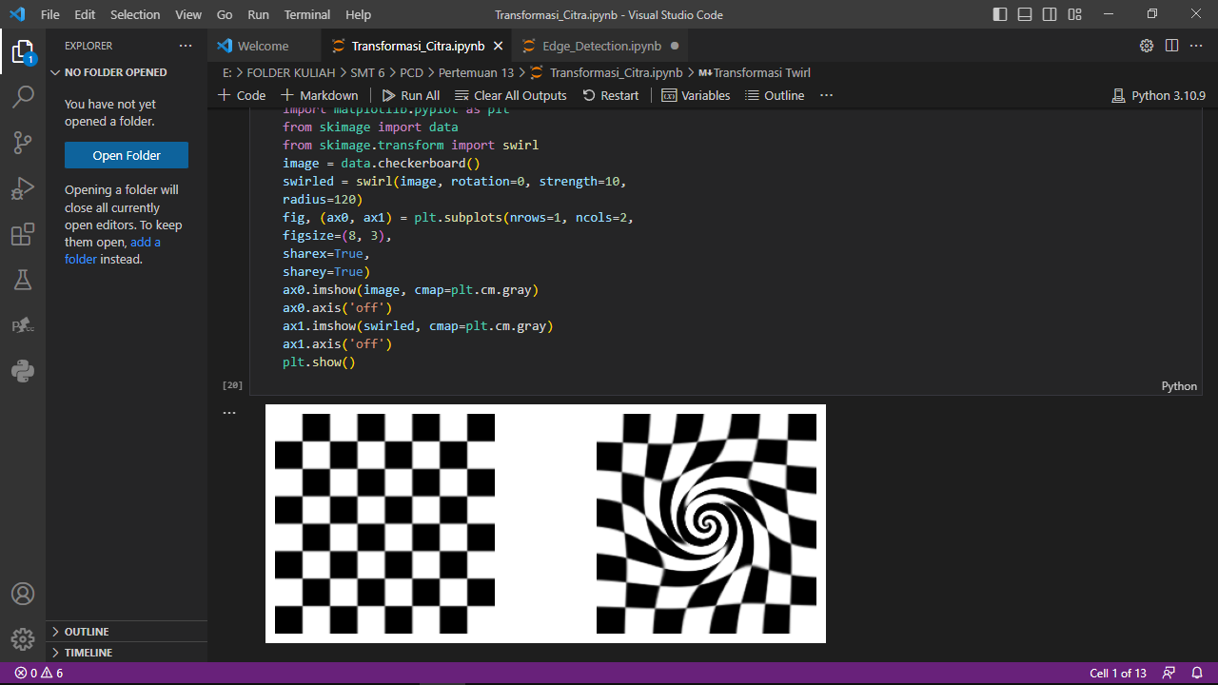

Translation

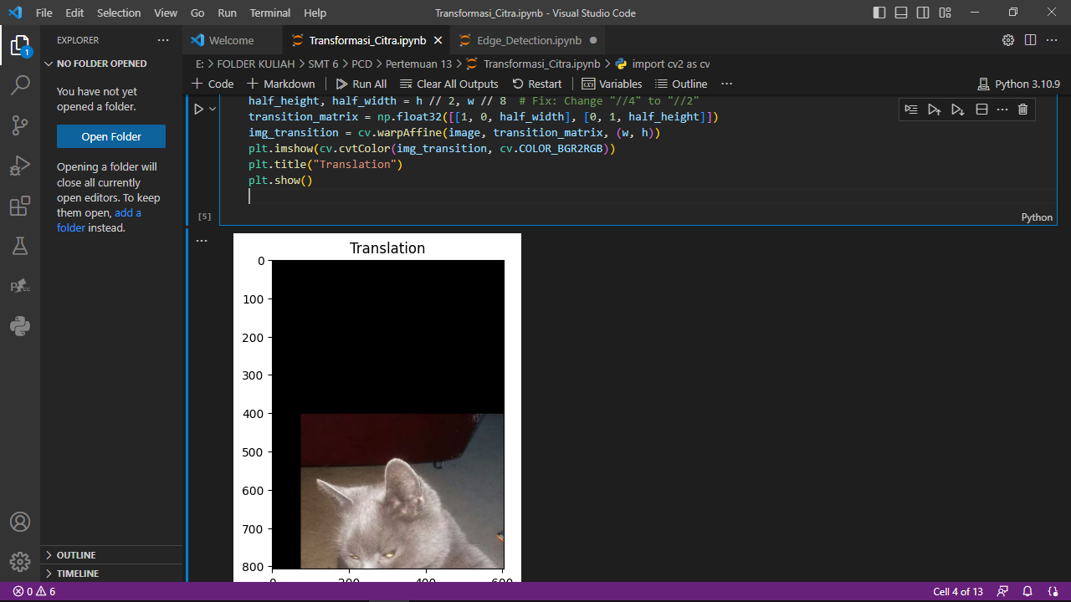

Rotation

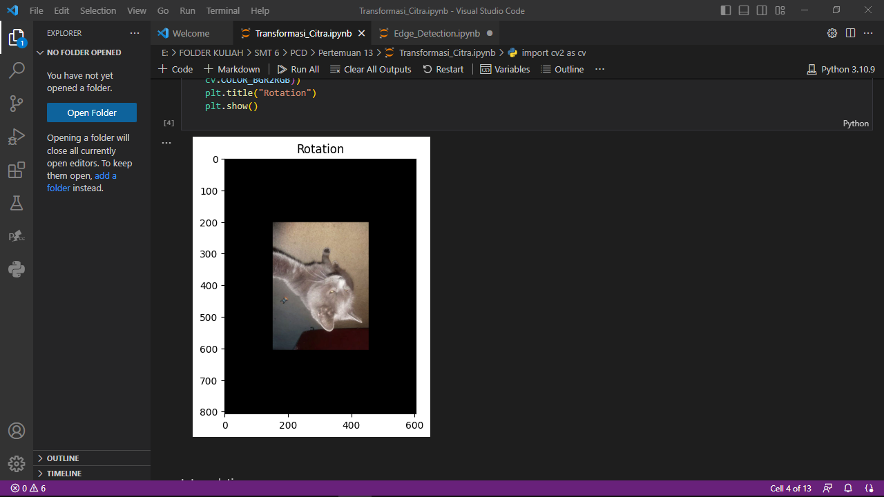

Interpolation

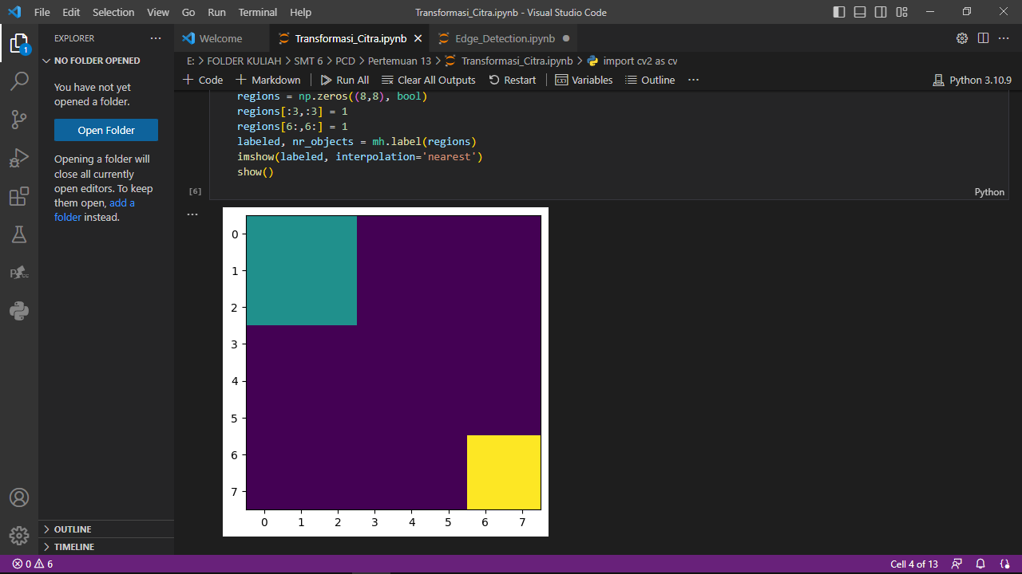

Skala Interpolasi

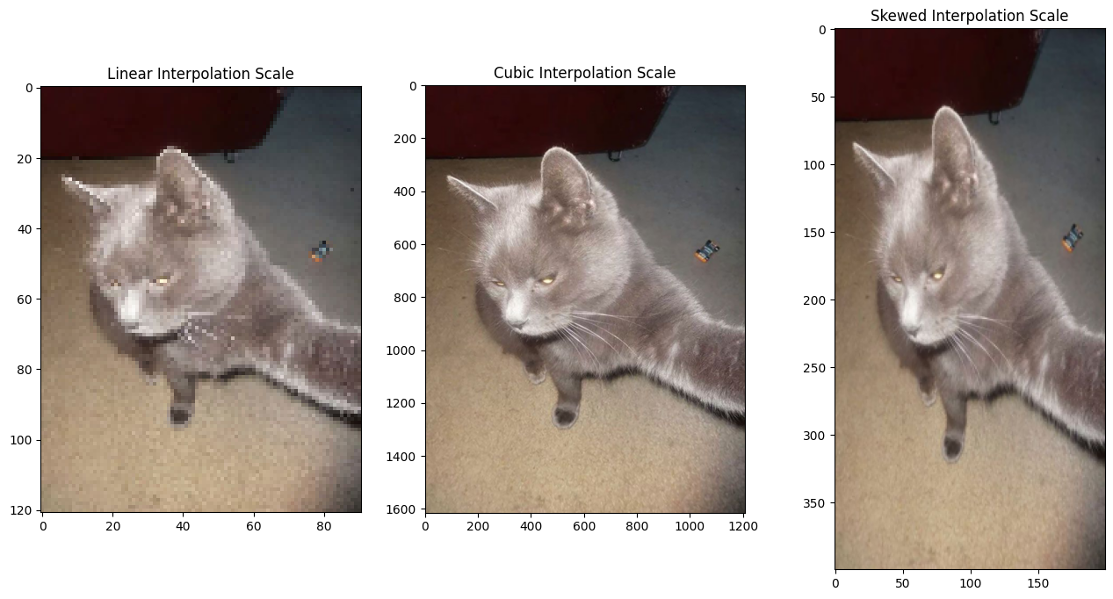

https://github.com/HaekalAlfan/1207070051_Haekal-Alfan-Permana_TransformasiCitra